



**UNIVERSIDAD TECNOLÓGICA DE**

**SAN LUIS RÍO COLORADO**

**PRACTICA 1**

**PROF. SOTO MORALES RICARDO ALEJANDRO**

**AUTOR(ES):**

***ESPINO TRIGUERAS LEONARDO SAHID***

***GALVAN COVARRUBIAS VICTOR MANUEL***

***MEZA ALVAREZ JUAN***

***PARRA SANCHEZ LESTAT***

***VEGA SAUCEDA ALAN GUADALUPE***

San Luis Rio Colorado, Sonora                                         junio, 2020

**Video link:**

[**https://drive.google.com/file/d/1ouoHQXDq283aJccHKKYYz1aJbsoKXIA0/view?fbclid=IwAR0d5GGiWwkoXTH7YuAjvMLUsqsF_AlekJshCVijnHxwSm7a3YHocPgu7_A**](https://drive.google.com/file/d/1ouoHQXDq283aJccHKKYYz1aJbsoKXIA0/view?fbclid=IwAR0d5GGiWwkoXTH7YuAjvMLUsqsF_AlekJshCVijnHxwSm7a3YHocPgu7_A)

**What is SOA?**

* It is an architectural approach in which applications make use of services available in the network.
* In this architecture, services are provided to form applications, through a communication call over the internet.
* Its principles are independent of vendors and other technologies.
* In [service oriented architecture](http://santexgroup.com), a number of services communicate with each other, in one of two ways: through passing data or through two or more services coordinating an activity.

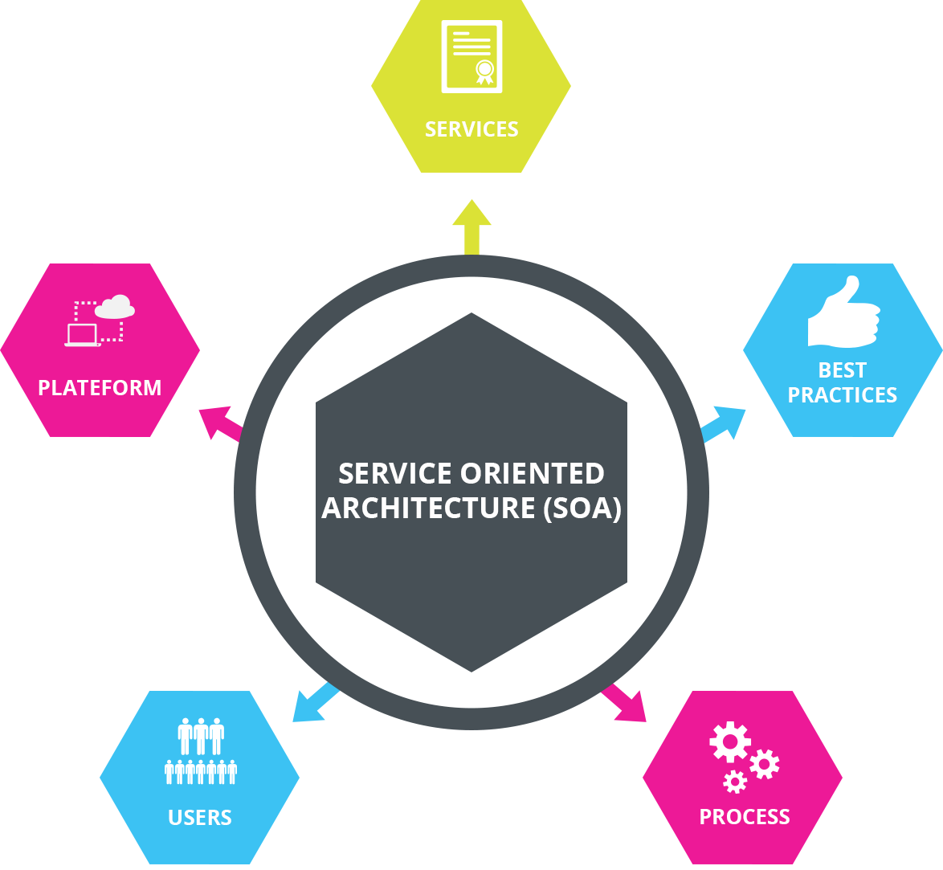

**Competitive advantage**

* Cost reduction and efficiency.
* Greater organization.
* Easier maintenance.
* Agile administration.
* It responds to its own needs.
* Facilitates innovation and adaptation.
* It allows creating personalized services.
* Let’s you take advantage of big data.

**The transition to service-oriented architecture**

**SOA is not new.**

* It requires an analysis of design and development techniques to advance with guarantees of success discarding inefficiencies.
* Organizations that already work with SOA but seek to optimize their results with Data Services will have to observe the following rules:
* Be demanding with the granularity of the chosen service, avoiding extremes and pursuing coherence.
* Understand the services as something limited and not as a complete application.
* Applying maximum simplicity when designing, after all, is about representing business actions.
* Guarantee the high availability and scalability of services.

**This optimization is the best way to overcome the limitations of a SOA project, through the visualization of data that helps to avoid:**

* Lack of availability of the dependent service.
* Lack of availability of resources.
* Time constraints.
* Dependent service behavior change.

**SOA Architectural Approaches**

* Web services, either done by developing brand new applications or just wrappers around existing legacy systems to make them network-enabled.
* Free range of architectures, operate independently of specific technologies.
* High level programing such as BPEL and specs as WS-CDL to deploy composite applications or portals.